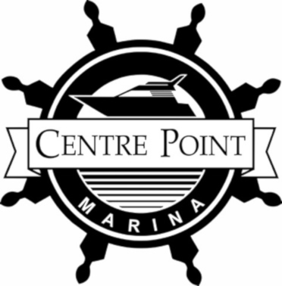
COVID – 19 Centre Point Marina
Guidelines For Safe Re-opening

- Mask/Face covering over mouth and nose must be worn at all times on the property, docks and in washroom facilities
- Please allow only one household in the washroom at a time – knock before entering and wait if the room is occupied
- All buildings except for washrooms are closed until further notice
  - If you need assistance or service, please call 705-738-3463
- Please go from vehicle to boat
- Should you use a boat tote; please sanitize before and after use with the bottle provided. It is also safe to use on hands so clean, clean away
- Max of 5 people on the docks at a time – if you come to someone, please move onto a finger dock to allow for social distancing and proceed after they move
  - Please be mindful of other members on the docks before leaving your boat
- Docking will remain touchless for the season at the gas dock and in your slip
- When re-fueling: tie up your boat, remove your gas cap and stand back 6-feet so our crew can fill up your vessel. After they have filled the tank please remember to put your cap back on.
  - Payments can be sent by e-transfer to: centrepointmarina@hotmail.ca to reduce contact in our buildings

Thank you for your cooperation in keeping our marina and crew safe for boating this season. Enjoy your summer!

Centre Point Crew

